**Thesis Cover Guide**

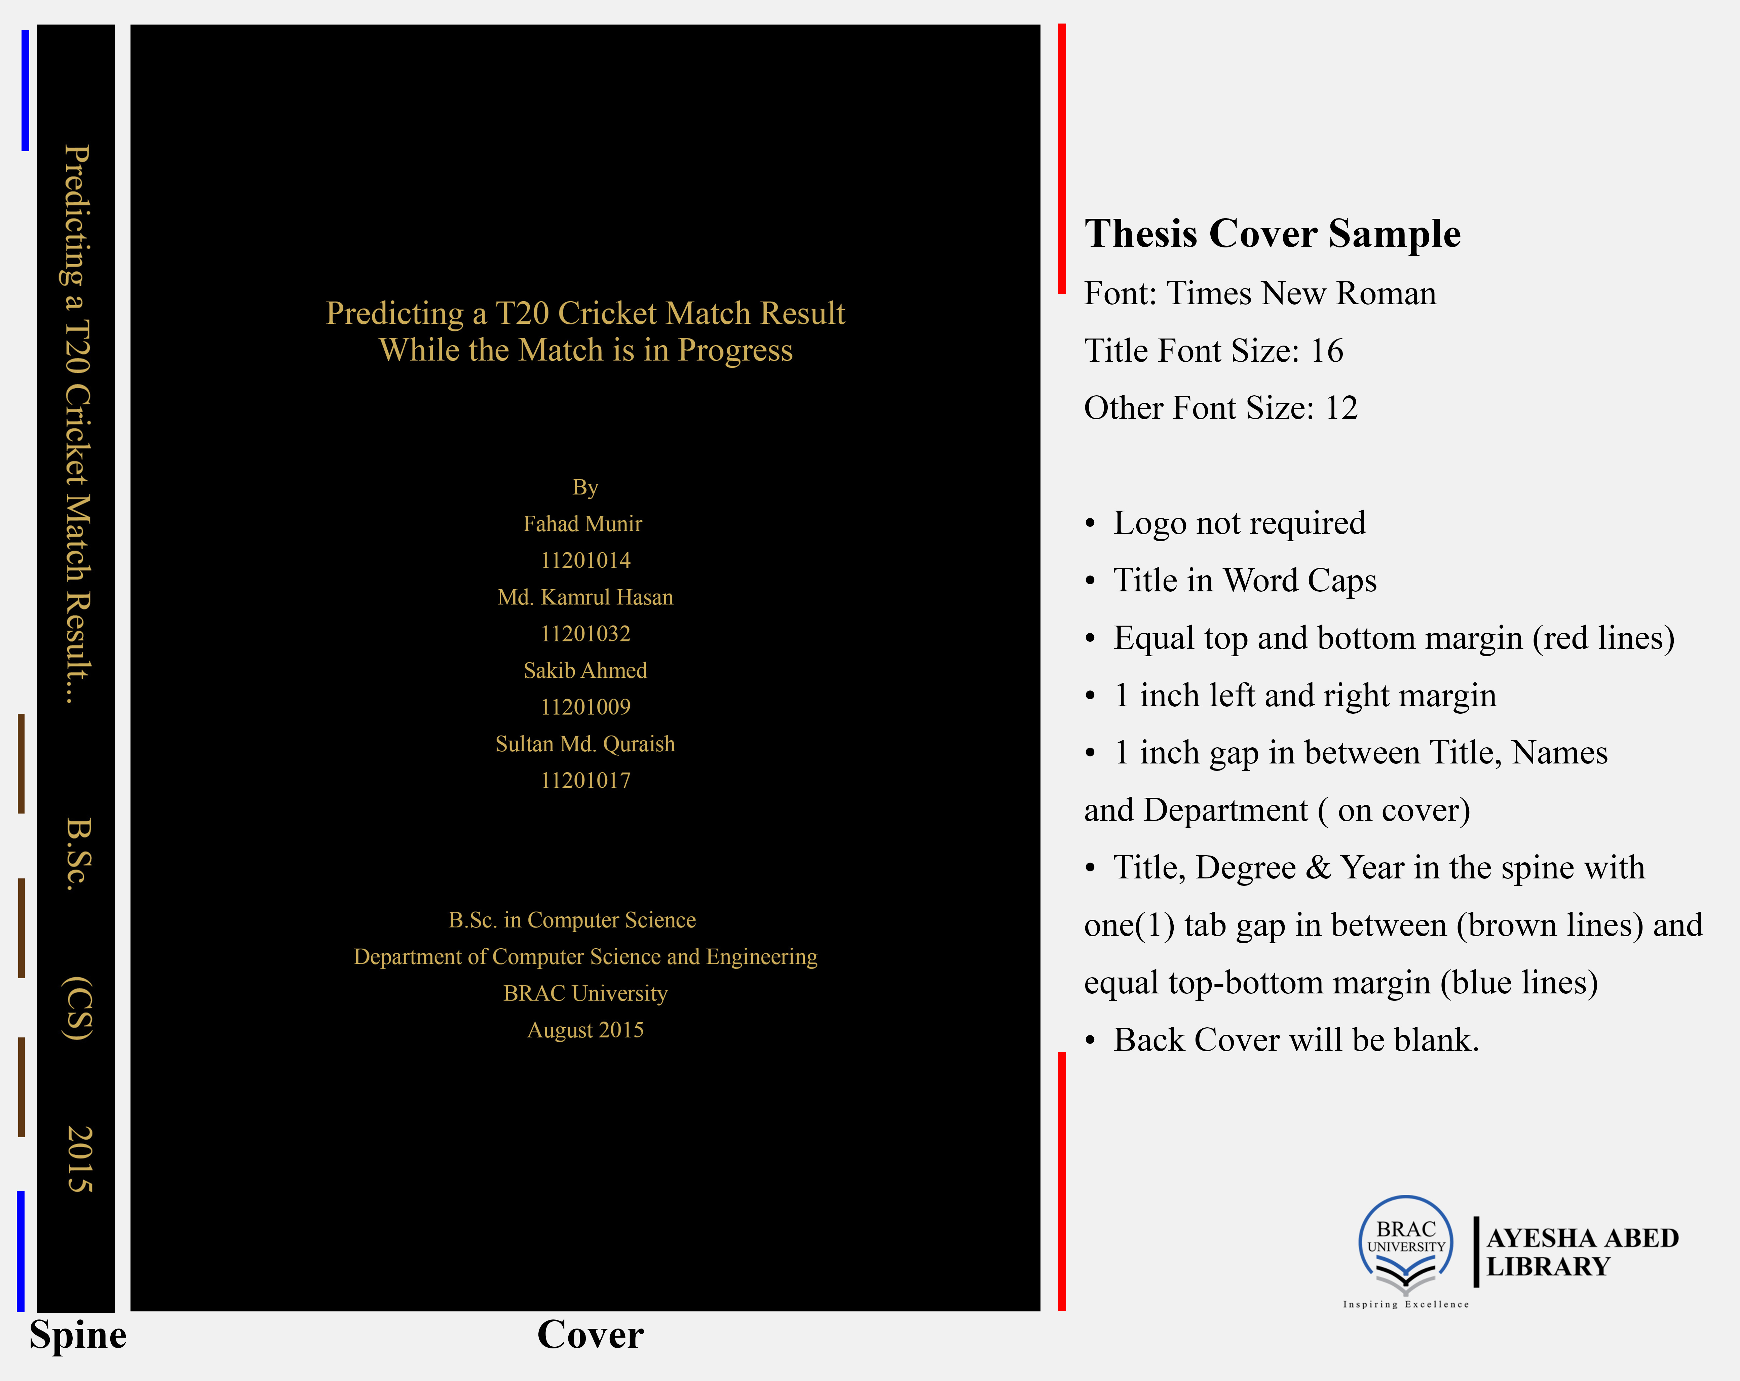

**For Thesis Template:**

Download the university thesis template from the link below.

[***http://library.bracu.ac.bd/sites/default/files/thesis_template/BRACU_Thesis_TemplateV1.docx***](http://library.bracu.ac.bd/sites/default/files/thesis_template/BRACU_Thesis_TemplateV1.docx)

**Note:**

1. University name must be written as “Brac University” or “BRAC UNIVERSITY”. Do not write university name as “BRAC University”
2. Please check the “**Department & Degree Titles for Cover & Spine of Thesis and Project Report**” for your department & degree names.

**Report Cover Page**

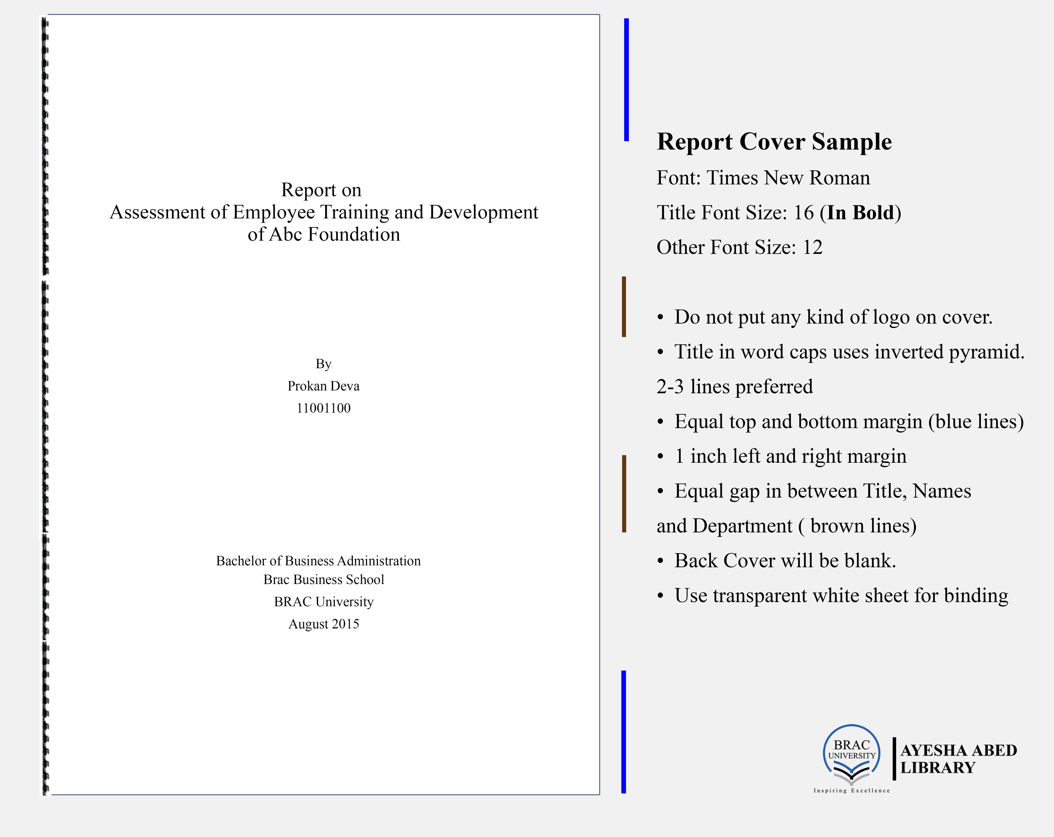

**For Report Template:**

Download the university report template from the link below.

[***http://library.bracu.ac.bd/sites/default/files/thesis_template/BRACU_Report_TemplateV1.docx***](http://library.bracu.ac.bd/sites/default/files/thesis_template/BRACU_Report_TemplateV1.docx)

**Note:**

1. University name must be written as “Brac University” or “BRAC UNIVERSITY”. Do not write university name as “BRAC University”
2. Please check the “**Department & Degree Titles for Cover & Spine of Thesis and Project Report**” for your department & degree names.

**Binding**

Please check acceptable binding preference as follows  
Note: Hard Cover of report/thesis shall be in black with gold lettering

* **Undergraduate Thesis (Architecture):** Hard Cover
* **Undergraduate Thesis:** Spiral Binding / Hard Cover
* **Undergraduate Report:** Spiral Binding
* **Master’s Thesis:** Hard Cover

**How to Cite / Reference?**

Please check the [Style Guides & Citation Builders](http://library.bracu.ac.bd/style-guides-and-resources) for details on APA, MLA, IEEE, and Chicago styles.

Please check the “Citation Examples” in this document for APA, IEEE & MLA examples.

**Where do I Look for Resources?**

Visit the library[Resources](http://library.bracu.ac.bd/resources) page.

You can check the [Subject Guide](http://library.bracu.ac.bd/subject-guides) page, which is designed to help you find information and access materials relevant to your department.

**Where do I Look for Previous Thesis & Reports?**

Find pervious thesis, dissertation and internship reports at [dspace.bracu.ac.bd](http://dspace.bracu.ac.bd/)

**Department & Degree Titles for Cover & Spine of Thesis and Project Report**

**Department of Architecture**

|  |  |  |
| --- | --- | --- |
| **On Title Page and Front Cover**  **of Binding** | **Department Name**  **on Cover** | **On Spine**  **of Binding** |
| Bachelor of Architecture | Department of Architecture | B.Arch |
| Master in Disaster Management | Department of Architecture | MA (DM) |

**Brac Business School**

|  |  |  |
| --- | --- | --- |
| **On Title Page and Front Cover**  **of Binding** | **Department Name**  **on Cover** | **On Spine**  **of Binding** |
| Bachelor of Business Administration | Brac Business School | BBA |
| Master of Business Administration | Brac Business School | MBA |
| Executive Master of Business Administration | Brac Business School | EMBA |
| Master of Bank Management | Brac Business School | MBM |

**Department of Computer Science and Engineering**

|  |  |  |
| --- | --- | --- |
| **On Title Page and Front Cover**  **of Binding** | **Department Name**  **on Cover** | **On Spine**  **of Binding** |
| Bachelor of Science in Computer Science | Department of Computer Science and Engineering | B.Sc. (CS) |
| Bachelor of Science in Computer Science and Engineering | Department of Computer Science and Engineering | B.Sc. (CSE) |
| Master of Science in Computer Science and Engineering | Department of Computer Science and Engineering | M.Sc. (CSE) |
| Master of Engineering in Computer Science and Engineering | Department of Computer Science and Engineering | M.Engg. (CSE) |
| Master of Computer Application | Department of Computer Science and Engineering | MCA |

**Department of Electrical and Electronic Engineering**

|  |  |  |
| --- | --- | --- |
| **On Title Page and Front Cover**  **of Binding** | **Department Name**  **on Cover** | **On Spine**  **of Binding** |
| Bachelor of Science in Electrical & Electronic Engineering | Department of Electrical and Electronic Engineering | B.Sc. (EEE) |
| Bachelor of Science in Electronic & Communication Engineering | Department of Electrical and Electronic Engineering | B.Sc. (ECE) |
| Master of Science in Electrical & Electronic Engineering | Department of Electrical and Electronic Engineering | M.Sc. (EEE) |
| Master of Engineering in Electrical & Electronic Engineering | Department of Electrical and Electronic Engineering | M.Engg. (EEE) |

**Department of Economics and Social Sciences**

|  |  |  |
| --- | --- | --- |
| **On Title Page and Front Cover**  **of Binding** | **Department Name**  **on Cover** | **On Spine**  **of Binding** |
| Bachelor of Social Science in Economics | Department of Economics and Social Sciences | BSS (Economics) |
| Bachelor of Social Science in Anthropology | Department of Economics and Social Sciences | BSS (Anthropology) |
| Master of Science in Applied Economics) | Department of Economics and Social Sciences | M.Sc. (Applied Economics) |

**Department of English and Humanities**

|  |  |  |
| --- | --- | --- |
| **On Title Page and Front Cover**  **of Binding** | **Department Name**  **on Cover** | **On Spine**  **of Binding** |
| Bachelor of Arts in English | Department of English and Humanities | BA (ENH) |
| Master of Arts in English | Department of English and Humanities | MA(ENH) |

**Department of Mathematics and Natural Sciences**

|  |  |  |
| --- | --- | --- |
| **On Title Page and Front Cover**  **of Binding** | **Department Name**  **on Cover** | **On Spine**  **of Binding** |
| Bachelor of Science in Applied Physics and Electronics | Department of Mathematics and Natural Sciences | B.Sc. (APE) |
| Bachelor of Science in Physics | Department of Mathematics and Natural Sciences | B.Sc. (PHY) |
| Bachelor of Science in Mathematics | Department of Mathematics and Natural Sciences | B.Sc. (MATH) |
| Bachelor of Science in Biotechnology | Department of Mathematics and Natural Sciences | B.Sc. (Biotech) |
| Bachelor of Science in Microbiology | Department of Mathematics and Natural Sciences | B.Sc. (Microbiology) |
| Master of Science in Biotechnology | Department of Mathematics and Natural Sciences | M.Sc. (Biotech) |

**Department of Pharmacy**

|  |  |  |
| --- | --- | --- |
| **On Title Page and Front Cover**  **of Binding** | **Department Name**  **on Cover** | **On Spine**  **of Binding** |
| Bachelor of Pharmacy (Hons) | Department of Pharmacy | B Pharm |

**School of Law**

|  |  |  |
| --- | --- | --- |
| **On Title Page and Front Cover**  **of Binding** | **Department Name**  **on Cover** | **On Spine**  **of Binding** |
| Bachelor of Laws (LL.B.) | School of Law | LL.B |

**Brac Institute of Governance and Development**

|  |  |  |
| --- | --- | --- |
| **On Title Page and Front Cover**  **of Binding** | **Department Name**  **on Cover** | **On Spine**  **of Binding** |
| Master of Arts in Governance and Development | Brac Institute of Governance and Development | MAGD |
| Master of Development Studies | Brac Institute of Governance and Development | MDS |
| Master in Development Management and Practice | Brac Institute of Governance and Development | MDMP |
| Master in Procurement and Supply Management | Brac Institute of Governance and Development | MPSM |

**Brac Institute of Languages**

|  |  |  |
| --- | --- | --- |
| **On Title Page and Front Cover**  **of Binding** | **Department Name**  **on Cover** | **On Spine**  **of Binding** |
| Master of Arts in TESOL | Brac Institute of Languages | MA (TESOL) |

**James P Grant School of Public Health**

|  |  |  |
| --- | --- | --- |
| **On Title Page and Front Cover**  **of Binding** | **Department Name**  **on Cover** | **On Spine**  **of Binding** |
| Master of Public Health | James P Grant School of Public Health | MPH |

**Brac Institute of Educational Development**

|  |  |  |
| --- | --- | --- |
| **On Title Page and Front Cover**  **of Binding** | **Department Name**  **on Cover** | **On Spine**  **of Binding** |
| Master of Science in Early Childhood Development | Brac Institute of Educational Development | M.Sc. (ECD) |

**Citation Examples**

**APA Citation Examples**

**Book:**

Creswell, J. W. (2007). *Qualitative inquiry and research design: Choosing among five traditions* (2nd ed.). Thousand Oaks: Sage Publications.

**Edited Book**

Hart, S., & Murphy, J. (Eds.). (1998). *Brands: The New Wealth Creators* (1st ed.). Palgrave Macmillan.

**Book Chapter**

Onyiriuba, L. (2017). Bank Assets Portfolio Structure and Risk Management in Developing Economies. In *Bank Risk Management in Developing Economies: Addressing the Unique Challenges of Domestic Banks* (1st ed., p. 668). Massachusetts: Academic Press.

**In-text Citation**

Branding was originally conceived as a technique to establish a product’s name and to convey the prestige of the manufacturer. However, this has evolved into the modern branding paradigm built upon abstraction and cultural engineering, where products embody consumer’s ideals and are only tenuously linked to functional benefits (Chapleo, 2015).

**In-text Citation with no date:**

Branding was originally conceived as a technique to establish a product’s name and to convey the prestige of the manufacturer (Association, n.d.).

**Citation with no date**

Association, A. L. (n.d.). Libraries and the IoT. Retrieved October 5, 2018, from http://www.ala.org/tools/librariestransform/future/blog/fri-05122017-0844

**Conference Proceedings**

Sevier, R. A. (1997). Major trends affecting higher education. In *Marketing of Higher Education*. Boston, USA.

Karasmanis, S. &, & Murphy, F. (2014). Emerging roles and collaborations in research support for academic health librarians. In *Australian Library and Information Association Biennial Conference* (pp. 1–13). Melbourne: Australian Library and Information Association. https://doi.org/10.13140/2.1.1089.1521

**Journal Article**

Chapleo, C. (2015). Brands in higher education: Challenges and potential strategies. *International Studies of Management and Organization*, *45*(2), 150–163. https://doi.org/10.1080/00208825.2015.1006014

**Report**

Hensel, N. (1991). *Realizing Gender Equality in Higher Education: The Need To Integrate Work/Family Issues. 1991 ASHE-ERIC Higher Education Report 2.* Washington.

**Thesis/Dissertation**

Ahmed, S., Munir, F., Hasan, M. K., & Quraish, S. M. (2015). *Predicting a T20 cricket match result while the match is in progress*. BRAC University. Retrieved from http://dspace.bracu.ac.bd/xmlui/handle/10361/4372

**Web Page**

Palmieri, A. (2017). Building the University Brand. Retrieved from https://thefrontrow.2u.com/university-branding-33e85e1091be

**Magazine Article**

Rosen, J. (2016, September). The Bangladeshi Traffic Jam That Never Ends. *The New York Times*. Retrieved from <https://www.nytimes.com/2016/09/23/t-magazine/travel/dhaka-bangladesh-traffic.html>

**Newspaper Article**

Ahmed, M. (2018, April 12). Salvaging our higher education. *The Daily Star*. Retrieved from https://www.thedailystar.net/opinion/society/salvaging-our-higher-education-1561396

**IEEE Examples**

**Book:**

[1] F. Duckworth, T. Lewis, and N. Newman, *Your Comprehensive Guide to the Duckworth/Lewis Method for Resetting Targets in One-day Cricket*. University of the West of England, 1999.

**Book with Chapter Title:**

[2] N. J. Nilsson, “Uninformed Search,” in *Artificial Intelligence: A New Synthesis*, 1st ed., San Francisco: Morgan Kaufmann Publishers, Inc., 1998, pp. 129–138.

**In-text Citation**

In some planning problems, like the one about block stacking, it is not too difficult to conceive of data structures for representing the different world states and the actions that change them. Typically though, finding representations that result in manageable state-space graphs is difficult. [2].

**Journals/Periodicals:**

[3] T. Tulabandhula and C. Rudin, “Tire Changes, Fresh Air, and Yellow Flags: Challenges in Predictive Analytics for Professional Racing,” *Big Data*, vol. 2, no. 2, pp. 97–112, 2014.

[4] D. R. Choudhury, P. Bhargava, and S. Kain, “Use of Artificial Neural Networks for Predicting the Outcome of Cricket Tournaments,” *Int. J. Sport. Sci. Eng.*, vol. 1, no. 2, pp. 87–96, 2007.

**Articles from published conference proceedings:**

[5] V. V. Sankaranarayanan, J. Sattar, and L. V. S. Lakshmanan, “Auto-play: A Data Mining Approach to ODI Cricket Simulation and Prediction,” in *Proceedings of the 2014 SIAM International Conference on Data Mining*, 2014, pp. 1064–1072

**Conference Paper (Paper Presented at a Conference)**

[6] D. Caratelli, M. C. Viganó, G. Toso, and P. Angeletti, “Analytical placement technique for sparse arrays,” presented at the 32nd ESA Antenna Workshop, Noordwijk, The Netherlands, Oct. 5–8, 2010

**Report:**

[7] R. E. Haskell and C. T. Case, “Transient signal propagation in lossless isotropic plasmas,” USAF Cambridge Res. Labs., Cambridge, MA, USA, Rep. ARCRL-66-234 (II), 1994, vol. 2.

[8] P. Diament, S. L. Richert, and W. L. Lupatkin, “V-line surface-wave radiation and scanning,” Dept. Elect. Eng., Columbia Univ., New York, NY, USA, Sci. Rep. 85, Aug. 1991.

**Report Online**

[9] R. J. Hijmans and J. van Etten, “Raster: Geographic analysis and modeling with raster data,” R Package Version 2.0-12, Jan. 12, 2012. [Online]. Available: http://CRAN.R-project.org/package=raster

**Thesis:**

[10] N. Kawasaki, “Parametric study of thermal and chemical nonequilibrium nozzle flow,” M.S. thesis, Dept. Electron. Eng., Osaka Univ., Osaka, Japan, 1993.

**Website:**

[11] J. Smith and J. Doe. “Obama inaugurated as President.” CNN.com. http://www.cnn.com/POLITICS/01/21/obama_inaugurated/index.html (accessed Feb. 1, 2009).

**MLA Citation Examples**

**Book:**

Creswell, John W. *Qualitative Inquiry and Research Design: Choosing among Five Traditions*. 2nd ed., Sage Publications, 2007.

**Edited Book**

Bronstein, Phyllis, and Kathryn Quina, editors. *Teaching a Psychology of People: Resources for Gender and Sociocultural Awareness*. 4th ed., Amer Psychological Association, 1988.

**Book Chapter**

Onyiriuba, Leonard. “Bank Assets Portfolio Structure and Risk Management in Developing Economies.” *Bank Risk Management in Developing Economies: Addressing the Unique Challenges of Domestic Banks*, 1st ed., Academic Press, 2017, p. 668.

**In-text Citation**

Branding was originally conceived as a technique to establish a product’s name and to convey the prestige of the manufacturer (Chapleo).

**In-text Citation with no date:**

Leonard suggested that as librarians we should “think through the eyes of our users.” She argued that emerging technologies depend on the target user. In other words, context matters (Association).

**Citation with no date**

Association, American Library. “Libraries and the IoT.” *American Library Association*, http://www.ala.org/tools/librariestransform/future/blog/fri-05122017-0844. Accessed 5 Oct. 2018.

**Conference Proceedings**

Sevier, R. A. “Major Trends Affecting Higher Education.” *Marketing of Higher Education*, 1997.

Karasmanis, Sharon &., and Fiona Murphy. “Emerging Roles and Collaborations in Research Support for Academic Health Librarians.” *Australian Library and Information Association Biennial Conference*, Australian Library and Information Association, 2014, pp. 1–13, doi:10.13140/2.1.1089.1521.

**Journal Articles**

Chapleo, Chris. “Brands in Higher Education: Challenges and Potential Strategies.” *International Studies of Management and Organization*, vol. 45, no. 2, 2015, pp. 150–63, doi:10.1080/00208825.2015.1006014.

**Thesis/Dissertation**

Ahmed, Sakib, et al. *Predicting a T20 Cricket Match Result While the Match Is in Progress*. BRAC University, 2015, http://dspace.bracu.ac.bd/xmlui/handle/10361/4372.

**Report**

Hensel, Nancy. *Realizing Gender Equality in Higher Education: The Need To Integrate Work/Family Issues. 1991 ASHE-ERIC Higher Education Report 2.* no. 5, 1991.

**Web Page**

Palmieri, Alicia. *Building the University Brand*. 2017, https://thefrontrow.2u.com/university-branding-33e85e1091be.

**Magazine Article**

Rosen, Jody. “The Bangladeshi Traffic Jam That Never Ends.” *The New York Times*, Sept. 2016, https://www.nytimes.com/2016/09/23/t-magazine/travel/dhaka-bangladesh-traffic.html.

**Newspaper Article**

Ahmed, Manzoor. “Salvaging Our Higher Education.” *The Daily Star*, 12 Apr. 2018, https://www.thedailystar.net/opinion/society/salvaging-our-higher-education-1561396.

**Need help?**

Need help to get started with your research, send an email to [*librarian@bracu.ac.bd*](mailto:librarian@bracu.ac.bd?Subject=Need%20help%20with%20research)